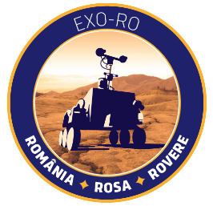
Registration Form
Exo-RO National Rover Competition for High School Students
Institution: ________________________________________________________________
City: ____________________________________
Team name: _____________________________
Name of coordinating teacher: _______________________________________________
Coordinating teacher e-mail address: __________________________________________
Coordinating teache phone no.: _______________________________________________
The coordinating teacher of the team is directly responsible for the correctness of the documents for participation in the competition and for the strict compliance with the terms and conditions of the Exo-RO National Rover Competition. He/she is responsible for the security, integrity and discipline of the students, and compliance with the regulations by them during any phase of the competition.
Please note: The members of the team can not be modified during the competition, no matter the circumstances. Team members:
No. | Name | Surname | Grade | Age
1.
2.
3.
4.

Project proposal:
Please note: Incomplete forms will not be accepted. Please try to reply to the best of your abilities.
Organisation
How will you distribute the work between the team members? Consider all aspects of your
experiment (structure, software,data analysis, etc.)
How much time will you have available to work on your rover and how will you spend
it?
How do you plan to finance your expenses? Are yousupported by your school or
other sponsors?
Do you have all the material and equipment needed for your mission? If not, how do you plan to obtain it?
Scientific mission
What is the secondary mission that you have
chosen for your Exo-RO?
Outline the scientific or technical objective of your secondary mission and highlight any innovative aspects.
Where did you get the idea from? e.g. from a real space mission, another rover project, a scientific publication, a book, etc.
Describe your secondary mission. This part should link the scientific objective to the
experiment itself. Explain how you are going to fulfill the scientific goal.
Which data will you measure
and how?
How do you plan to control the rover? ( sensors and telecomm protocols)
What is the data obtained and how are you going to analyze it?
Outreach
Describe your outreach program campaign. e.g. newspaper articles, local radio, webpage,
presentation at school, etc. ( Please include links to FB, TW or other platforms)

Please complete this form and return it by e-mail to exo-ro@rosa.ro until 17 July 2016, 23:59. The terms and conditions of the contest are available online here.
I declare knowing art. 292 of the Criminal Code regarding false statements, that the information provided in this form is true.
Name
Signature
Date
__/__/____

